**InsightStream: Navigate the News Landscape**

**Ideation Phase**

**Empathize & Discover**

|  |  |
| --- | --- |
| Date | 31 January 2025 |
| Team ID | SWTID1741257268149879 |
| Project Name | InsightStream: Navigate the News Landscape |
| Maximum Marks | 4 Marks |

**Empathy Map Canvas:**

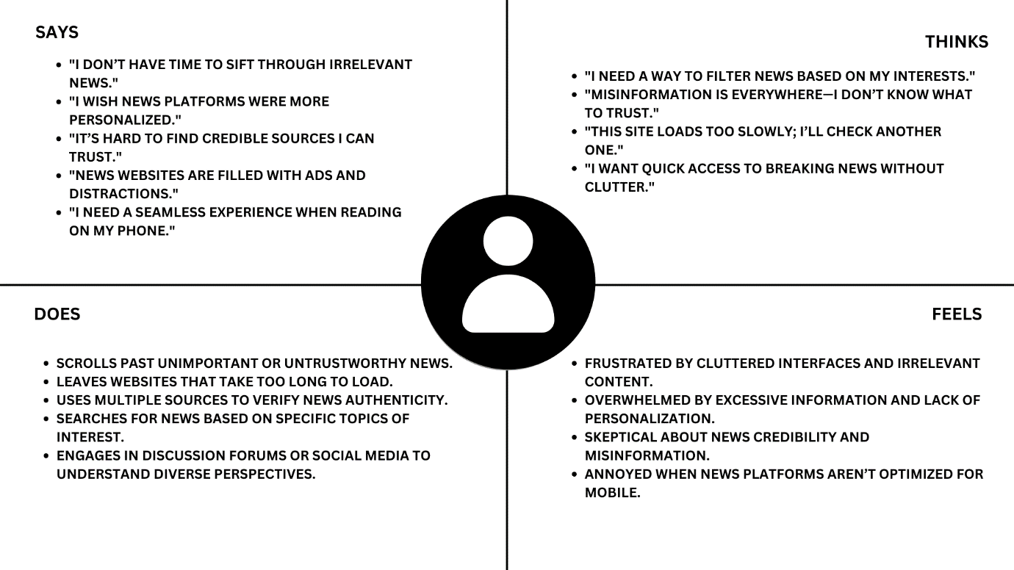

# ****Understanding the Modern News Consumer: Challenges and Expectations****

In today’s fast-paced digital world, news consumers face several challenges while seeking reliable and relevant information. The modern reader is overwhelmed with excessive content, misinformation, and cluttered news platforms, leading to frustration and distrust. Understanding their behavior, thoughts, and emotions can help news platforms create better experiences for their audience.

## ****What News Consumers Say****

Users often express their dissatisfaction with the current state of online news platforms:

* "I don’t have time to sift through irrelevant news."
* "I wish news platforms were more personalized."
* "It’s hard to find credible sources I can trust."
* "News websites are filled with ads and distractions."
* "I need a seamless experience when reading on my phone."

These statements reflect the need for efficiency, trustworthiness, and mobile-friendly experiences in news consumption.

## ****What News Consumers Think****

In addition to their direct feedback, users have specific thoughts regarding their news experience:

* "I need a way to filter news based on my interests."
* "Misinformation is everywhere—I don’t know what to trust."
* "This site loads too slowly; I’ll check another one."
* "I want quick access to breaking news without clutter."

These concerns highlight the demand for better content filtering, faster website performance, and a more streamlined way to access reliable news.

## ****What News Consumers Do****

To cope with these challenges, users adopt certain behaviors:

* Scroll past unimportant or untrustworthy news.
* Leave websites that take too long to load.
* Use multiple sources to verify news authenticity.
* Search for news based on specific topics of interest.
* Engage in discussion forums or social media to gain diverse perspectives.

These habits indicate that users actively seek control over their news consumption, preferring sources that provide quick, reliable, and engaging content.

## ****How News Consumers Feel****

The frustrations of modern news consumers shape their emotions:

* Frustrated by cluttered interfaces and irrelevant content.
* Overwhelmed by excessive information and lack of personalization.
* Skeptical about news credibility and misinformation.
* Annoyed when news platforms aren’t optimized for mobile.

Understanding these emotions can help media companies develop solutions that improve user satisfaction and trust.

## ****How News Platforms Can Improve the Experience****

To address these concerns, news organizations can adopt the following strategies:

1. **Personalization** – Implement AI-driven recommendations to deliver news based on user preferences.
2. **Credibility Verification** – Partner with fact-checking organizations to provide verified news.
3. **Minimalist Design** – Reduce ads and distractions for a clean reading experience.
4. **Mobile Optimization** – Ensure fast-loading, mobile-friendly websites.
5. **Breaking News Alerts** – Offer quick and clutter-free updates for important events.

By prioritizing user needs, news platforms can build trust and engagement, creating a better experience for modern readers.